

**Institutional Repository**

**https://ir.uwf.edu/**

**Add your works to the Argo IRCommons**

Pre-print, post-print and published works from current and retired UWF faculty, research symposiums and conferences and student research projects are eligible.

All scholarly works are welcome in the IR:

Journal articles

Theses/dissertations

Books, book chapters

Conference presentations/posters

Data sets

Films, videos, photographs

And more….

**ARGO**

**IRCommons**

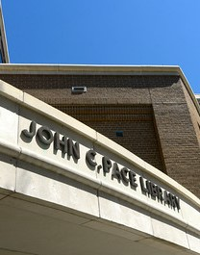



11000 University Parkway

Pensacola, FL 32514

850.474.2424

850.474.2414

uwf.edu/library

**uwf.edu/library**

**uwf.edu/department**

 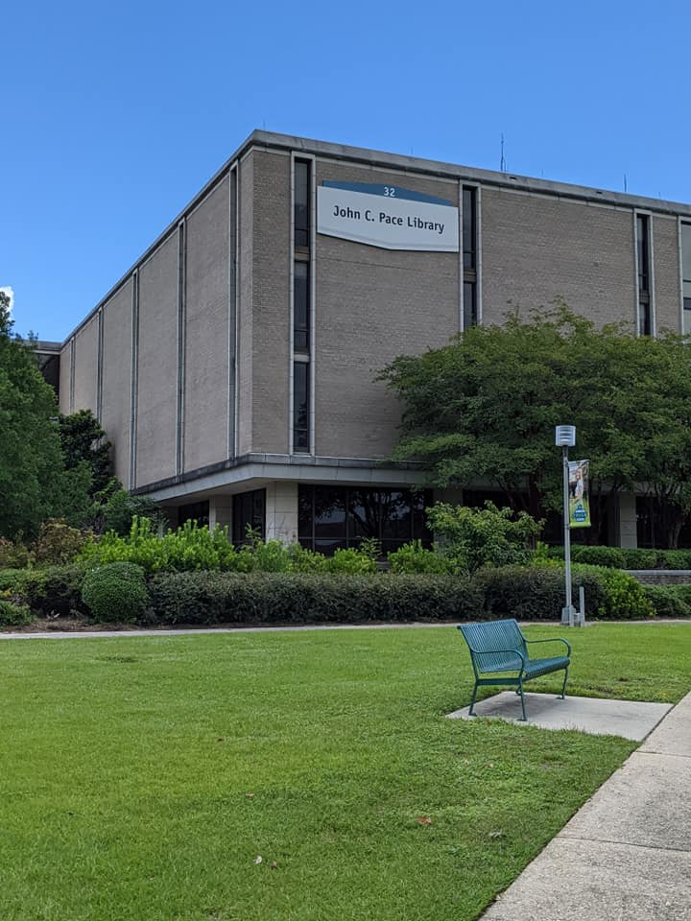

**Why should you contribute?**

The UWF Argo IRCommons is a digital collection that captures, stores, indexes, preserves and disseminates the scholarly output of the University of West Florida community and makes it available worldwide.

Argo IR serves as a showcase for the research and creative output of UWF.

Works placed in the IR are easily discovered using common search engines making it easier for researchers around the world to discover your work. Users can then cite your work with a permanent URL.

The Argo IR opens up the accessibility of your content, increasing its discoverability and usability, allowing you to gain a wider distribution of scholarly output.

**Preserve your scholarly legacy with the Argo IR**

The Argo IR complements traditional publishing and can expedite immediate access to your scholarly work. Submitting your works to the Argo IR may satisfy grant requirements to publicly disseminate the results of grant-generated research.

**University Libraries | UWF**

**How to contribute:**

Just complete an authorization form and University Libraries will create your profile and deposit materials for you.

We create the metadata, such as keywords and abstracts, to help indexing systems (such as Google Scholar) find your materials. The IR can accommodate materials in print, audio and audio-visual formats. We are happy to scan and digitize any works not already in digital format. We manually review every published document’s copyright and publisher’s policies to ensure that we are in compliance.

For more information, and a link to the UWF IR authorization form, see http://libguides.uwf.edu/IR

**University Libraries | UWF**